2/7/2024

Adithia V

*ADITHIA.AD73@GMAIL.COM*

21 Analytics KPIs for eCommerce.

Understanding and Measuring Key Performance Indicators for Olist's eCommerce operations.

#### Analytics KPI -01: Percentage Distribution of Customers in Each State.

The Percentage Distribution of Customers in Each State (KPI) measures the proportion of customers residing in each state relative to the total customer base. It provides insights into the geographic distribution of customers within a dataset or business context, highlighting regions with higher and lower customer concentrations. This KPI is useful for understanding regional customer demographics, targeting marketing efforts effectively, and optimizing logistics and customer service strategies based on geographical demand.

São Paulo (SP) has the highest percentage at nearly 42%, followed by Rio de Janeiro (RJ) and Minas Gerais (MG), while states like Roraima (RR) and Amapá (AP) have the lowest percentages, each below 0.1%.

This distribution highlights the significant concentration of customers in a few key states, particularly in the southeastern region of Brazil, with São Paulo leading by a large margin.

#### Analytics KPI - 02: Order Rate per date

Order Rate Per Date is a (KPI) used to measure the efficiency and effectiveness of order processing within a specific timeframe. This metric is critical for understanding customer demand patterns, operational performance, and overall business health.

The highest number of orders was placed on 2017-11-24 with 1176 transactions, which accounted for 1.18% of the total orders in the dataset.

The top 5 order rates per date occurred between November 24, 2017, and November 28, 2017. This suggests that a significant event or promotion may have occurred during that time frame.

#### Analytics KPI - 03: Cancellation Rate.

Cancellation Rate is a (KPI) that measures the percentage of orders that were canceled compared to the total number of orders in a specific time frame.

The cancellation rates for most dates are very low, except for August 07, 2018 (0.00905%). The consistently low cancellation rates indicate effective order management and high levels of customer satisfaction.

#### Analytics KPI - 04: Delivery Rate.

Delivery Rate is a (KPI) measures the percentage of orders that are successfully delivered to customers within a specified time frame.

Between November 24, 2017, and November 28, 2017, when the number of orders per date was at its peak, the delivery rate was also at its peak.

#### Analytics KPI – 05: Average Delivery Time.

The Average Delivery Time (KPI) measures the average time it takes for orders to be delivered to customers after they are ordered. It is a critical metric for assessing operational efficiency and customer satisfaction in e-commerce and retail businesses.

The average delivery time on September 15, 2016(55), was significantly higher than the average delivery time for the second highest on October 03, 2016(27).

Among the top 10 dates with high average delivery time, the average delivery time for 4 dates falls within the first week of October 2016.

#### Analytics KPI – 06: Total Order Value based on order date.

The Total Order Value (KPI) measures the sum of monetary value generated from all orders processed within a specified time frame.

The highest Total Order Value is 152,653.74 on November 24, 2017, and the lowest Total Order Value is 9,152.35 on August 22, 2017.

#### Analytics KPI – 07 Items Per Order.

The Items Per Order (KPI) measures the number of items a customer purchases per order. It is a useful metric for understanding customer buying behavior and can provide insights into sales strategies, product bundling, and inventory management.

There is a general increasing trend in the average items per order from mid-September to mid-October.

The mean average items per order is approximately 1.50.

#### Analytics KPI – 08 Average Product Price per order.

The Average Product Price Per Order (KPI) measures the average price of products purchased in a single order. This KPI is valuable for understanding the average value of items customers are buying.

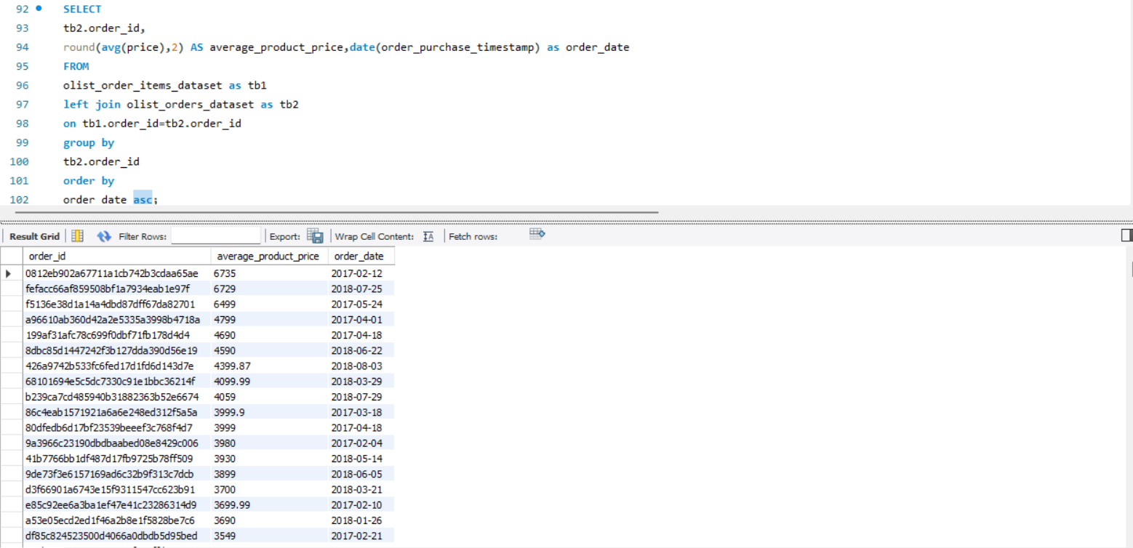

The top 10 orders ranked by item count differ from the top 10 orders ranked by average price per order, which shows varying priorities in customer purchasing behavior and spending patterns.

In 2016, the average product price per order was the lowest compared to 2017 and 2018, indicating an increase in the average product price per order year by year.

#### Analytics KPI – 09 Highest Category Sales Value.

The highest category sales value (KPI) refers to the category that generates the most revenue or sales for a business. This KPI is crucial for understanding which segments of products are most successful in driving revenue. It helps businesses prioritize marketing efforts, inventory management, and overall business strategy.

Beleza e Saúde (Beauty and Health): This category has the highest sales value, indicating strong consumer demand in health and beauty products.

Relógios e Presentes (Watches and Gifts): Close behind the beauty category, suggesting popularity in accessories and gift items.

Cama, Mesa e Banho (Bed, Table, and Bath): Strong performance in household goods, essential for daily living.

#### Analytics KPI – 10 Average Freight Value Per Order.

The Average Freight Value Per Order (KPI) is a metric used to measure the average cost of shipping per order within an eCommerce business. It's calculated by dividing the total freight costs by the number of orders processed within a specific timeframe. This KPI is crucial for understanding shipping cost efficiency and its impact on overall profitability.

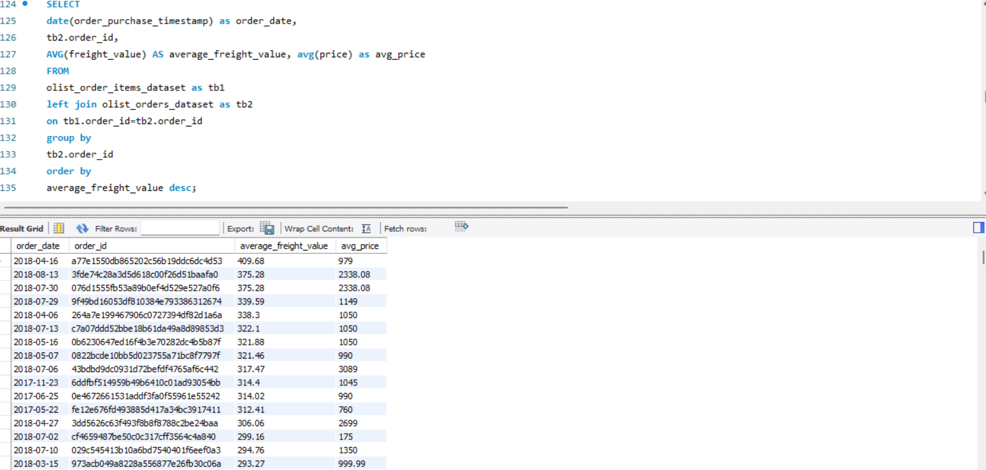

Highest average freight value for an order is 409.68.

There are popular orders with high average freight order values that have been ordered multiple times by customers, indicating their popularity. Reducing the freight value for these orders could increase overall profitability.

#### Analytics KPI – 11 Common Payment Type.

The Common Payment Type (KPI) typically refers to the most frequently used payment methods by customers in eCommerce transactions. Understanding the common payment types is crucial for optimizing checkout processes, ensuring customer convenience, and potentially reducing transaction costs.

Credit cards are the most used payment method, indicating a preference for convenience and possibly benefiting from installment payment options.

Boleto Bancário remains a significant payment method, especially in Brazil where it's popular due to its widespread acceptance and cash-based nature.

#### Analytics KPI – 12 Payment Value Per Order.

The Payment Value Per Order (KPI) measures the average amount of payment received per order in an eCommerce business. It provides insights into the average transaction value and helps assess the effectiveness of pricing strategies, product offerings, and customer purchasing behavior.

Four of the lowest total payment value orders were purchased within a 10-day period (2018-08-25 to 2018-09-03). There might have been seasonal sales, discounts, or promotions during that period, encouraging customers to make low-value purchases.

#### Analytics KPI – 13 Average Installment Payment Value.

The Average Installment Payment Value (KPI) measures the average value of installment payments made by customers per transaction. This metric is particularly useful in eCommerce businesses that offer installment payment options, allowing you to understand the typical installment payment size and manage credit risk effectively.

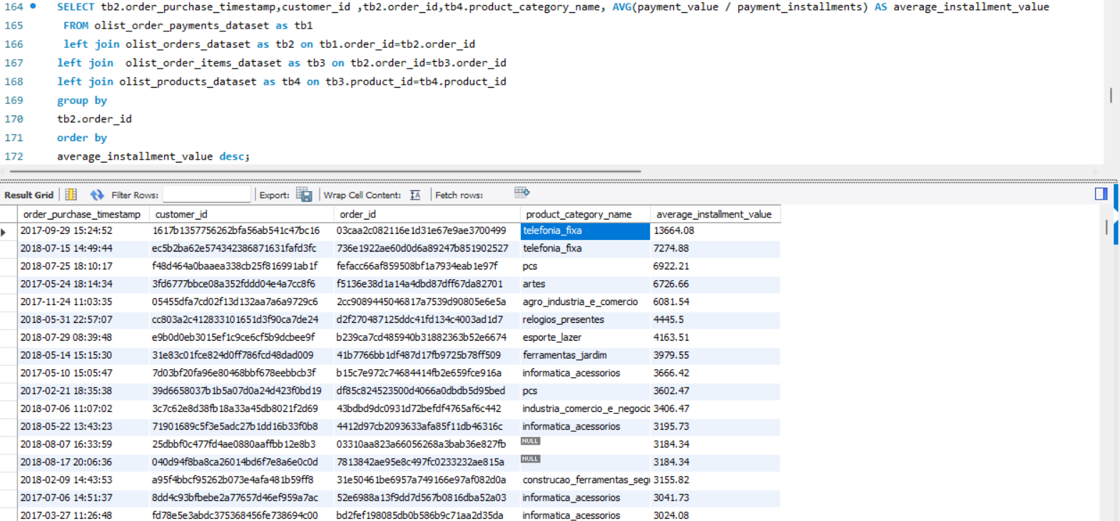

Highest average installment payment was $13,664, which was ordered on November 29,2017.

Top 2 average installment payment belong to Telefonia fixa (fixed-line telephony).

Most of the highest average installment payments were made by distinct customers, indicating unique customer behavior

#### Analytics KPI – 14 Distribution of Product Categories.

The Distribution of Product Categories KPI measures the sales performance across different product categories in an eCommerce business. It helps in understanding which categories contribute most to overall sales and can guide inventory management, marketing strategies, and business focus.

Top 5 Popular Product Categories are Cama, Mesa e Banho (Bed, Table, and Bath): 3,029, Esporte e Lazer (Sports and Leisure): 2,867, Móveis e Decoração (Furniture and Decoration): 2,657, Beleza e Saúde (Beauty and Health): 2,444, Utilidades Domésticas (Household Utilities): 2,335

#### Analytics KPI – 15 Average Price of Products in Each Category.

The Average Price of Products in Each Category KPI in eCommerce refers to the mean price of products sold within specific product categories. It is a metric used to analyze pricing strategies, understand customer purchasing behavior, and assess market competitiveness within each category.

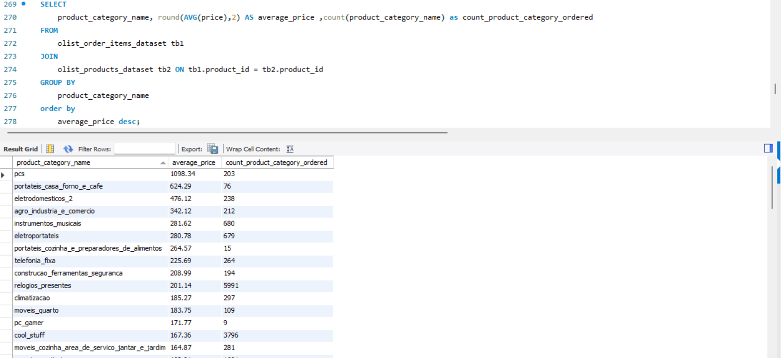

PCS (Average Price: $1,098.34) and Portable Home Appliances and Coffee (Average Price: $624.29) have relatively high average prices.

Watches and Gifts (Relógios e Presentes) (Number of Orders: 5,991) stands out with a significantly high number of orders despite a moderate average price ($201.14). This indicates strong demand and popularity among customers, possibly due to seasonal trends or high gifting appeal.

#### Analytics KPI – 16 Highest Product Review Score.

The Highest Product Review Score (KPI) tracks the products with the highest average review score across all products sold on an eCommerce business. It typically involves calculating the average rating on a scale of 1 to 5 given by customers who have purchased and reviewed the product.

Products with high review scores indicate customer satisfaction and build trust among potential buyers.

#### Analytics KPI – 17 Delivery Performance.

The Delivery Performance (KPI) measures the efficiency and reliability of the delivery process in an eCommerce business. It tracks key metrics related to order fulfillment and delivery times to ensure that customers receive their orders within the estimated timeframe.

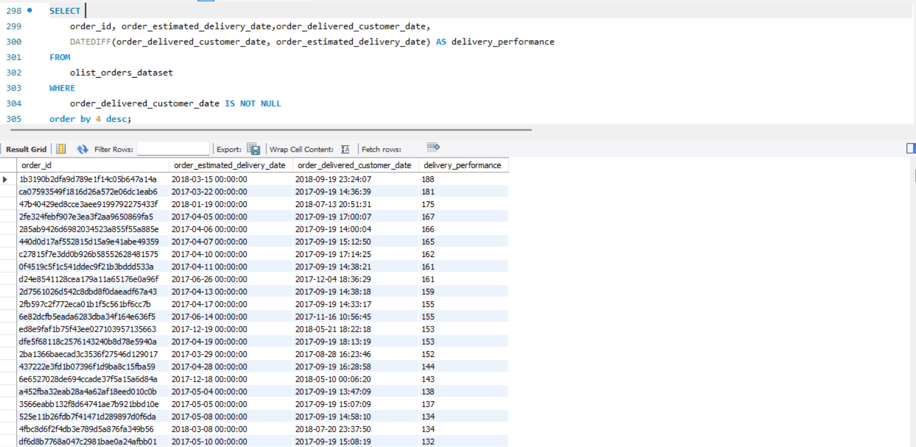

The data reveals significant issues with delivery performance, as 66 orders took more than 80 days beyond their estimated delivery time to be delivered.

Above 180 Days: 3 orders,150 to 180 Days: 11 orders, 100 to 150 Days: 31 orders, 80 to 100 Days: 21 orders

#### Analytics KPI – 18 Relationship Between Product Categories and Payment Methods.

The Relationship Between Product Categories and Payment Methods (KPI) measures the correlation between different product categories and the payment methods used by customers. This helps to identify patterns and preferences in payment methods for various product categories, providing insights for optimizing payment options and marketing strategies.

Top Product Categories by Credit Card: cama_mesa_banho [bed_bath_table]: 8959 transactions, beleza_saude [health_beauty]: 7566 transactions, esporte_lazer [sports_leisure]: 6635 transactions, moveis_decoracao [furniture_decor]: 6379 transactions, informatica_acessorios [computers_accessories]: 5436 transactions

Top Product Categories by Boleto: informatica_acessorios [computers_accessories]: 2158 transactions, cama_mesa_banho [bed_bath_table]: 1875 transactions, beleza_saude [health_beauty]: 1860 transactions, esporte_lazer [sports_leisure]: 1772 transactions, moveis_decoracao [furniture_decor]: 1735 transactions

Top Product Categories by Voucher: cama_mesa_banho [bed_bath_table]: 847 transactions, esporte_lazer [sports_leisure]: 411 transactions, moveis_decoracao [furniture_decor]: 530 transactions, utilidades_domesticas [housewares]: 505 transactions, relogios_presentes [watches_gifts]: 255 transactions

#### Analytics KPI – 19 Correlation Between Review Scores and Product Prices.

The Correlation Between Review Scores and Product Prices (KPI) measures and analyze the relationship between product review scores and product prices, providing insights into how product pricing might influence customer satisfaction and perceived value.

A possible inverse relationship between review scores and product prices, with lower scores corresponding to higher average prices.

#### Analytics KPI – 20 Top-Selling Product Categories.

The Top-Selling Product Categories (KPI) measures and ranks the performance of product categories based on sales volume or revenue. This KPI provides insights into which categories are generating the most sales, helping businesses identify popular product segments and make informed inventory and marketing decisions.

The top-selling product categories, led by Beleza e Saúde (Beauty and Health) with $1,258,681.34 in sales revenue, followed closely by Relógios e Presentes (Watches and Gifts) at $1,205,005.68, and Cama, Mesa e Banho (Bed, Table, and Bath) with $1,036,988.68, demonstrate strong market demand and popularity based on their sales figures.

#### Analytics KPI – 21 The Unique Customers.

The Unique Customers (KPI) measures the number of individual customers who have made at least one purchase within a specified period. This metric helps eCommerce businesses understand their customer base size and gauge their reach and market penetration.

A total of 96,096 distinct customers have placed orders within the eCommerce platform.